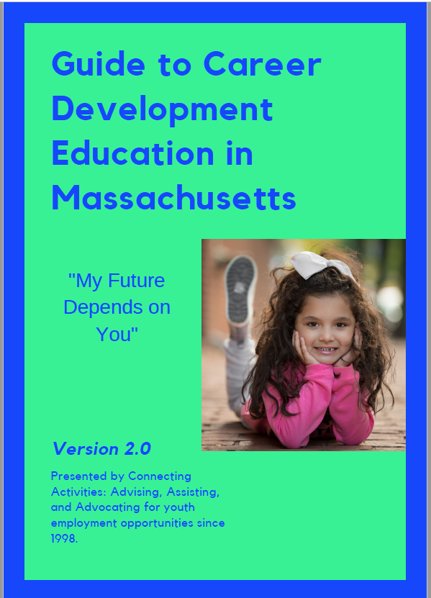

CAREER DEVELOPMENT EDUCATION GUIDE
TABLE OF CONTENTS
CAREER DEVELOPMENT EDUCATION GUIDE TABLE OF CONTENTS 1
Acknowledgements 3
Introduction 4
Purpose of the guide 4
Worldwide Context in Spring 2020 5
Section 1: Career Development Education 5
Section 2: The Importance of Career Development Education 6
Design of an Exemplary CDE Program: Guiding Principles and Design Characteristics 6
Section 3: Massachusetts Initiatives, Partnerships and Tools 8
Finding Communities of Practice and Supporting Resources 8
COMMON ACRONYMS AND TERMS USED in these communities of practice 9
Catalog of Programs, Initiatives, Resources and Tools 11
Workforce Development Partnerships 11
MassHire Workforce Boards: 11
Connecting Activities (CA) : 11
YouthWorks: 11
MassHire Career Centers: 11
Career Pathways 11
CVTE Programs 12
Innovation Pathways 12
Early College Pathway 12
Pathway Mapping Tool 12
Featured Massachusetts Tools 13
Elements of Model Internships 13
The Massachusetts Work-Based Learning Plan Resource Guide 13
A Primer for Labor Market Information 14
Regional Labor Market Blueprints 14
The Innovation Pathways Toolkit 14
Signal Success 15
The Massachusetts Career Ready Database 15
My Career and Academic Plan (MyCAP) Implementation Guide: 15
Contextual Learning Portal 16
Connecting Activities Annual Reports 16
Perkins V State Plan (for CVTE and HQCCP) 16
Section 4: Elements of a Strong CDE Program 17
Tips for the instructor, mentor, teacher, industry partner 17
Elements of a strong CDE program: Career Awareness 18
Career Day / Career Fair 18
Career Interest Inventory / Career Interest Assessments 18
Career Speakers 19
Labor Market Information Analysis 20
Service Learning / Community Service / Civic Awareness 21
Company Tours / Career-Related Field Trips 21
Individual Career Coaching/Guidance 22
Elements of a strong CDE program: Career Exploration 23
Career Exploration Courses 23
Career Skills Workshops 23
Financial and Economic Literacy Events and Workshops 24
Job Shadow Day 25
Mentorship programs 25
Mock Interviews / Informational Interviews 25
Vocational Exploratory Courses 25
Elements of a strong CDE program: Career Immersion 26
Capstone Projects / Senior Projects 26
Co-Curricular Activities and Clubs 27
Entrepreneurship Programs 27
Skills Portfolios 27
Industry-Recognized Credentials 28
Work-Based Learning Experiences 28
Virtual Internship 29
Elements of a strong CDE program: Connecting Schools, Families & Community 30
Family Events: Career Awareness for Students and Families: 30
Middle School Events: Career Awareness and Planning/High School Choices: 30
Teacher Externship Programs 30
Elements of a strong CDE program: The MyCAP Planning Process 31
ABOUT MyCAP 32
Section 5: A Local Vision for Career Development 33

Acknowledgements
CCTE Team  Cliff Chuang, Senior Associate Commissioner  Elizabeth Bennett, Associate Commissioner  Kerry Akashian, Career Development Education Lead  Jennifer Appleyard, Early Warning Implementation Specialist  Rebekah Barr, Early College Assistant  Larry DeSalvatore, CCTE Education Specialist  David Edmonds, CCTE Education Specialist  Ramona Foster, CCTE Education Specialist  Osly Flores, CCTE Education Specialist  Nyal Fuentes, CCR Specialist  Jennifer Gwatkin, Innovation Pathways Lead  Lisa Harney, Coordinator of Dropout Prevention & Recovery  Carrie Harrington, Management Analyst III  Kristin Hunt, Early College Director  Marnie Jain, CCTE Education Specialist  Jennifer Leonard, Consultant, Skills Library  Timothy Moriarty, Program Coordinator  Emily Meehan, Early College Assistant, LEE Fellow  Lisa Sandler, MOA State Coordinator  Lisa Weinstein, CCTE Education Specialist  Teacher Extern: Kerry Mulcahy, Ed.D., Doherty High School, Worcester | MassHire Workforce Boards  MassHire Berkshire Workforce Board: Heather Boulger, Heather Shogry-Williams, Kat Toomey  MassHire Boston Workforce Board: Neil Sullivan, Joshua Bruno, Bodi Luse  MassHire Bristol Workforce Board: Thomas Perreira, Nicholas Church  MassHire Cape and Islands Workforce Board: Kara Galvin  MassHire Central Region Workforce Board: Jeffrey Turgeon  MassHire Franklin Hampshire Workforce Board: Patricia Crosby, Matthew Allen  MassHire Greater Brockton Workforce Board: Sheila Sullivan-Jardim, David Edwards, Krystel Love  MassHire Greater Lowell Workforce Board: Peter Farkas, Beatrix Sierra  MassHire Greater New Bedford Workforce Board: Jim Oliveira, Andrea McLaughlin  MassHire Hampden County Workforce Board: David Cruise, Christine Abramowitz  MassHire Metro North Workforce Board: Chris Albrizio-Lee, Trey Walsh, Heather Derby  MassHire Merrimack Valley Workforce Board: Abel Vargas, Susan Almano, Cristy Gomez  MassHire Metro South/West: Greg Bunn, Meghan Burke  MassHire North Central Workforce Board: Jeff Roberge, Kelley French  MassHire North Shore Workforce Board: Mary Sarris, Katie Crowder  MassHire South Shore Workforce Board: Dean Rizzo, India Gerald, Mary Kate Paris  Cover Photo Credit to Katy Rogers of BPS student, Fallon K. Perez

Introduction
Massachusetts is committed to building a workforce ready for the jobs of tomorrow. There are many roles to fill so flexible approaches to workforce preparation is necessary. It is the goal of the Commonwealth of Massachusetts to prepare all students with the knowledge, skills, and experiences for college, career readiness, and civic preparation. Through academic preparation, workplace readiness, and personal and social development, students will be able to pursue economically viable career pathways and participate in civic and democratic life.

Over the past four years, the state of MA met ambitious goals and strengthened its college and career readiness system by streamlining efforts across state agencies, developing criteria for high quality career development education experiences, and transforming strategies for college and career advising. In addition, Massachusetts placed an increased attention on issues of equity and ensuring equitable outcomes for all students. As a result of this impactful work, DESE has scaled up the extent to which career development education experiences are offered to all students. This guide is designed to support the expansion of quality career development experiences. Read more about this system building work: http://www.doe.mass.edu/ccte/ccr/initiatives/nsfy-snapshot.pdf

Purpose of the guide
The purpose of the guide is to present a central document that provides guidance to districts and other stakeholders to more effectively understand, develop, implement, and optimize career development education programs and practices in MA. The guide is intended to offer greater clarity on key terminology, improve programmatic delivery and design, build district capacity, and ultimately shift district and school-wide practices to better support the career development education received by all students across the Commonwealth.
The guide is presented in four sections. The guide begins with Section 1 on career development education (CDE). Discussion continues in Section 2 on the importance of CDE. Section 3 addresses the Massachusetts initiatives and tools that support strong CDE. Section 4 presents the elements of a strong CDE program and includes the stages of career development education, guiding principles of high quality CDE programs, and stakeholder support. Section 5 reflects on how to create a local vision for Career Development Education and introduces the Appendices.
The guide is provided by Connecting Activities, a DESE-led initiative that advises, assists, and advocates for youth employment opportunities since 1998. Connecting Activities offers the guide to share best practices and help partners to think systematically about developing and enhancing career development education experiences for students in MA.
While career development is a lifelong process, the focus of this guide is on the K-12 years, as DESE is charged with preparing students for college and career, beginning in Kindergarten until graduating from high school.

Worldwide Context in Spring 2020
As we work on the revised version of this guide, physical schools are closed amidst a worldwide pandemic. This will be a defining moment for students’ education, as so much has changed in such a short amount of time. Educators, students and families are working diligently to establish distance learning practices. Manufacturing firms are racing to re-tool to produce medical supplies. Researchers are collaborating more closely than ever before to find treatments and vaccines. For students, this is a time when it may be overwhelming to think about the future, while it is also a time to gain new insights into the challenges and opportunities of an always-changing economy.
However, when school and work routines return to a new normal, students can return to physical and virtual classrooms with a new sense of how their academic work applies to civic, community and career settings. Decisions about postsecondary education and career will take on new levels of importance.

Section 1: Career Development Education
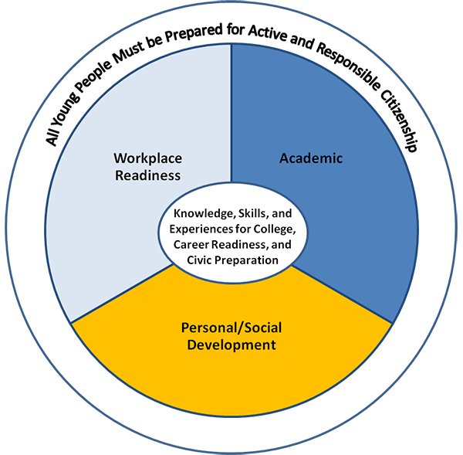
Career Development Education consists of a sequence of activities designed to provide students with skills, knowledge and experiences that equip them for next steps after high school. The outcome of career development education includes readiness for postsecondary education, first career steps and civic engagement, recognizing the importance of transferable skills and knowledge that are important in all of the aforementioned domains. The circle graphic featured here illustrates the Massachusetts definition of "College, Career and Civic Readiness," which is the desired outcome of effective CDE.
Within this definition, the exact path to college and career readiness can vary. Some students will participate in formal programs and pathways focused on specific career areas or industries, including Career/Vocational Technical Education programs, Innovation Pathway programs, and other career-related pathways and programs. Other students will participate in a mixture of career exploration activities, career-related courses, work-based learning experiences and capstone projects blended into a traditional high school program.

Section 2: The Importance of Career Development Education
CDE benefits individual students by providing a foundation for successful first career steps, while also benefiting the local and regional economy by opening up doors for students to pursue careers in emerging and high-demand careers. CDE benefits the overall school climate as well, as an important factor that increases school engagement and increases graduation rates. A schoolwide approach to quality CDE is an important tool for building educational equity for all. In Massachusetts, educators know that together we have the power to change student outcomes. It is imperative that we continuously refresh our offerings to ensure that we are providing all students with a chance to succeed in the 21st century and beyond.
Benefits to individual students: Quality career development education can change the directory of a person’s life and can contribute to financial and professional success and positive mental health outcomes. Additionally, quality CDE interventions can address inequities that exist for underserved students. For instance, early exposure to positive career development education experiences can increase labor force attachment for female adolescents, students with learning disabilities, and students of color. Benefits may come from increased self-confidence and an awareness of future options, opportunities to connect with caring adults both in the classroom and beyond the classroom, insights into the connection between academic, career and civic engagement skills, and insights into one’s own skills. View more details about CDE research research at http://massconnecting.org/research and resources for exploring issues of equity at http://massconnecting.org/equityresources.
Benefits to local and regional economies. The Massachusetts economy is dynamic, with newly emerging opportunities in fields that include: advanced manufacturing, information technology, healthcare, higher education and the arts. Business leaders are eager to connect with schools to share information about career opportunities that are important to the local and regional economy.
Benefits to schools. When school districts define and shape their vision, mission and goals, it is increasingly clear that career development education is a natural part of the mission of K-12 education. Positive career development experiences help students build transferable skills, provide context, motivation, and vision for their current and future academic work, and serve to increase school engagement, high school graduation rates and postsecondary educational success. Career development experiences are natural tools for increasing equity across all groups in the school, with clear messages about the wide range of postsecondary options that are available to all students and the support and mentoring available from local industry, higher education, and school district partners to support students in their next steps.

Design of an Exemplary CDE Program:
Guiding Principles and Design Characteristics
Shared from the Massachusetts High Quality College and Career Pathways initiative https://www.mass.gov/guides/creating-college-career-pathways, the following five guiding principles and six design characteristics form an overall guide to designing strong CDE programs. As a result of the knowledge acquired through the initiative, we encourage districts to utilize the elements of HQCCPs to guide the development of all career development activities.
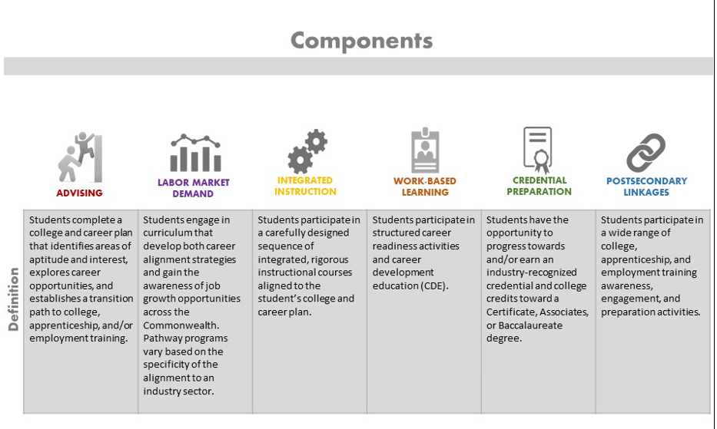
Five Guiding Principles:
Equitable Access: | Guided Academics: | Enhanced Student Support: | Connection to Career: | Effective Partnerships:
Prioritize students underrepresented in education enrollment and completion. To facilitate this, all CDE activities should be structured to eliminate barriers to student participation. | Offer exposure to the authentic experience and academic rigor of postsecondary education, and provide substantive exposure to career opportunities in high demand fields to enable youth to make more informed decisions about which careers to pursue. | Incorporate enough wraparound services, such as tutoring, mentoring, guidance counseling, and social and emotional support. | Expose students to a variety of career opportunities based on labor market research and allow for targeted workforce and career skills development, career counseling, and elements of experiential and work-based learning. | Engage key stakeholders to create quality CDE experiences for students. Partners can include institutes of higher education, guidance counselors, MassHire Workforce Board members, and employers.

Section 3: Massachusetts Initiatives, Partnerships and Tools

Career Development Education in Massachusetts is a collaboration among partners in K-12 education, higher education, workforce development and other youth-serving agencies. District and school leaders who are looking for resources to support Career Development Education in their district can work with the local Connecting Activities program to explore resources, looking at the landscape of potential partners and programs, which could include any of the following:

- Who is providing summer jobs programming in your community? Look for YouthWorks, WIOA Youth programs, as well as a variety of other state-funded or locally-supported programs.
- Who is providing programming targeted to particular populations, such as secondary transition programs for students with disabilities?
- Which local organizations are providing youth leadership, entrepreneurship, civic involvement or other community programming for youth?
- Which local business, civic and community organizations are interested in providing career guest speakers, scholarships, or other support for your students?
- Which local colleges and universities are interested in providing career development programming for your students?
- Who is providing programming targeted toward particular career areas, such as STEM Industry initiatives or Arts initiatives?
Through the MassHire Workforce Board and the Connecting Activities network, find out about local industry groups and businesses that would be interested in supporting career development and work-based learning for your school or district.

Finding Communities of Practice and Supporting Resources

The following pages provide a “catalog” of the landscape of career education partnerships and resources and tools that support schools in this work. Through publications conferences, meetings, online communication, and formal and informal networks, the initiatives form “communities of practice”, groups of practitioners who meet to discuss issues, highlight and review best practices, and troubleshoot problems of implementation . COP’s provide support for career development education and work-based learning. As school and district leaders become immersed in communities of practice, they will most likely identify overlapping themes and shared resources among each program or initiative, and will hopefully find a rich network of people who are eager to share and adapt resources and ideas to create high quality programming for youth.

COMMON ACRONYMS AND TERMS USED in these communities of practice
CDE | Career Development Education
CA | Connecting Activities
CVTE | Career/Vocational Technical Education (typically refers to programs approved under Chapter 74 of Massachusetts General Laws, often called “Chapter 74 programs”)
CTE | Career Technical Education (may be used as a synonym for CVTE, or may refer to Non-Chapter-74 programs, that is, programs not approved under Chapter 74)
IP | Innovation Pathway
EC | Early College Pathway
HQCCP | High Quality College and Career Pathway, an umbrella for CVTE, IP and EC programs
MyCAP | My Career and Academic Plan, a tool and system for career and academic planning
WBLP | Work-Based Learning Plan, the tool used to structure work-based learning experiences.
WBL | Work-Based Learning, a term to refer to work experience programs, including summer jobs, internships, cooperative education, and most recently “virtual internships”.
Industry | A group of businesses or organizations that engage in similar work, producing similar products or services, often with competition among organizations but also collaboration to support education and training, human resource development, industry-related research and other infrastructure for the industry.
Occupation | A set of professions with similar skill focus, such as accounting, carpentry, culinary arts or information technology.
Career Skills | A broad term referring to a set of skills that are important for success in a workplace, either in specific career paths or across all career paths. A career skill may be as specific as blueprint reading, food safety, CAD Drawing or HTML, or as broad as communication, critical thinking and creativity.

Catalog of Programs, Initiatives, Resources and Tools

Workforce Development Partnerships
MassHire Workforce Boards:  Workforce development initiatives for adults and youth are coordinated through a system of sixteen MassHire Workforce Boards, across sixteen regions in Massachusetts. The workforce boards coordinate the Connecting Activities initiative, with funding from the DESE, as well as the One Stop Career Centers, YouthWorks programs, labor market research programs and several other workforce training and educational programs.  Visit: https://www.mass.gov/service-details/connect-with-your-local-masshire-workforce-board | Connecting Activities (CA) :  Connecting Activities (CA) is a critical strategy for MA’s effort to ensure that all students are college and career ready and able to participate civically. It is a statewide network led by DESE and organized through sixteen MassHire Workforce Boards charged with supporting work-based learning and other career development education activities for students. CA provides the infrastructure for schools and partners to connect locally, regionally, and statewide and responds to the desire for strong college and career planning experiences. Through this network, educators can exchange ideas and practices by accessing a wide range of tools, resources, and experiences that support students. Also, CA leaders work to broker unsubsidized jobs for in school youth.  Website: http://www.doe.mass.edu/connect
YouthWorks:  YouthWorks is a state-funded youth employment program that helps teens and young adults get the skills and experience needed to find and keep jobs. Participants take part in paid short-term work placements during the summer and/or school year at public, private and nonprofit worksites. Participants also receive training in core soft skills so they can practice professional behaviors and learn how to relate to supervisors and co-workers at their worksites. They also learn how to take the next steps in their education and career pathways. All YouthWorks programs use the Signal Success curriculum to help young people learn and practice the skills that matter at work, at school, and in life. YouthWorks is coordinated through the MassHire Workforce Boards and collaborates with the Connecting Activities program.  Website: http://commcorp.org/youthworks | MassHire Career Centers:  The network of MassHire Career Centers (also called One-Stop Career Centers), through the sixteen MassHire Workforce Boards, provide career development workshops, resume writing, interview skills, job search and job training services for adults and youth.  In many regions of the state, many of the Connecting Activities programs include a close collaboration with the Career Centers, program staffing, workshops and other resources provided to schools through the Career Centers.  Visit: https://www.mass.gov/masshire-career-centers

Career Pathways

CVTE Programs
Career/Vocational Technical Education (CVTE) is a program of study focused on a specific career area. In Massachusetts, there are 45+ frameworks in career areas such as Advanced Manufacturing, Aviation Technology, Business Technology, Carpentry, Dental Assisting, Engineering Technology and more. CVTE programs are offered in regional vocational technical high schools as well as in district high schools. First-year students explore program options through a formal Exploratory program and then are immersed in their program for their remaining years of high school. Career development experiences include hands-on coursework, opportunities to earn industry-recognized credentials and opportunities to work in industry settings through Cooperative Education experiences.
Learn more: www.doe.mass.edu/ccte/cvte/

Innovation Pathways
Innovation Pathways are structures within our high schools that are designed to connect student learning to broadly-defined industry sectors that are in demand in the regional and state economy. Schools leverage strong partnerships with their local MassHire board and employers to provide students with career awareness and work-based learning activities. Students participate in a series of courses and experiences relevant to achieving industry recognized credentials. Students in Innovation Pathways participate in an immersive experience - either a 100-hour capstone or internship - that is aligned with the chosen industry sector. Read about Innovation Pathways and the accompanying designation process on the DESE website: http://www.doe.mass.edu/ccte/ccr/hqccp/

Early College Pathway
Early College pathway programs are designed to blend elements of high school and college to provide students with the opportunity to experience and complete college level academic coursework on a clearly articulated pathway and simultaneously gain exposure to a variety of career opportunities. Early college programs also reduce the time and expense of earning a college credential while increasing the likelihood of completion. Schools develop these pathways in collaboration with a postsecondary partner. Students earn college credits by taking college courses, related to their pathway focus. Also see: http://www.doe.mass.edu/ccte/ccr/hqccp/

Pathway Mapping Tool
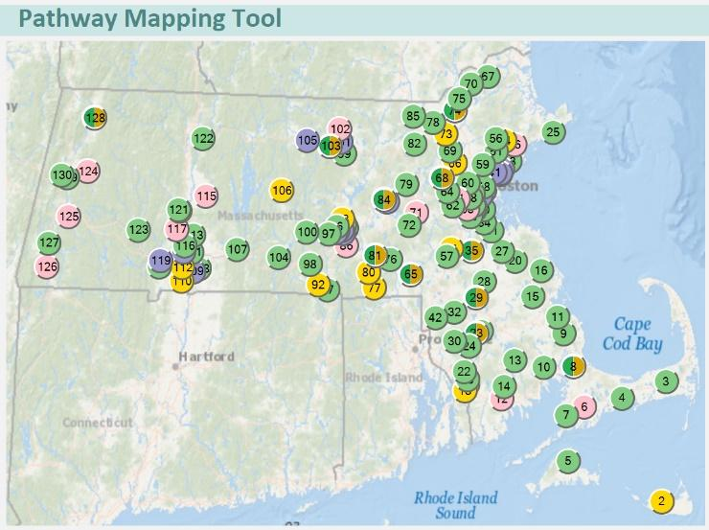
To see what types of pathways are offered in your city, town and region, see the Pathway Mapping Tool, found at http://massconnecting.org/pathwaymapping This tool provides a quick look at all of the CVTE, Innovation Pathway and Early College pathway programs in Massachusetts, along with an explanation of the different types of programs and pathways.
For school/district leaders interested in information about starting a program or pathway in your district, please visit the HQCPP pages on the DESE website at www.doe.mass.edu/ccte/

Featured Massachusetts Tools
This section of the catalog highlights just some of the tools provided by Connecting Activities, the MassHire Workforce Boards, and related initiatives, with an emphasis on resources created by CA to support Career Development Education. Additional resources and tools are highlighted in the following section about elements of high quality career development education.
Elements of Model Internships  The internship guide, found at http://massconnecting.org/internships provides tips for starting an internship program, along with examples of forms and materials from programs throughout Massachusetts.  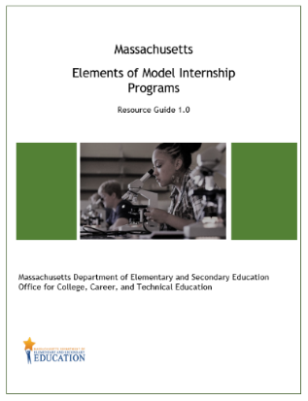 | The Massachusetts Work-Based Learning Plan Resource Guide  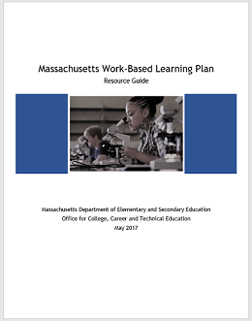  The Massachusetts Work-Based Learning Plan is used to structure and enrich work experiences for youth in a wide array of programs statewide. This guide, found at http://massconnecting.org/wblp provides links to the Massachusetts Work-Based Learning Plan, along with suggestions about how to use the Work-Based Learning Plan in a work experience program.
A Primer for Labor Market Information  A guide to finding and using labor market information in Massachusetts, designed to support schools and programs in using and understanding the wide range of available information. http://www.doe.mass.edu/connect/cde/primer-labormarket.docx  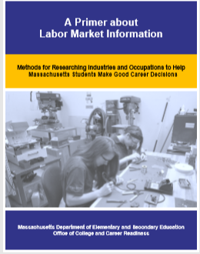 | Regional Labor Market Blueprints  Regional labor market blueprints can inform policy and practice at a state and local level. The following regional blueprints represent industry and occupational priorities for workforce investment in seven regions across the Commonwealth: Berkshire, Pioneer Valley, Central, Southeast, Cape, Greater Boston, and Northeast. The blueprints should be used to inform policy and practice in workforce development and career development programming.  https://www.mass.gov/service-details/view-your-regions-blueprint

The Innovation Pathways Toolkit
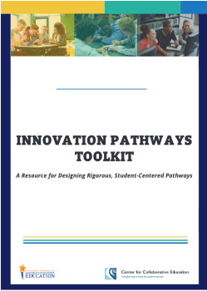
The Innovation Pathways Toolkit is designed for Innovation Pathways designees and future designees to:

- Provide structure and tools to design rigorous, student-centered pathways

- Support a variety of design, development, and implementation needs in a way that is customizable according to each school and pathway’s particular context.

Website: https://sites.google.com/view/innovation-pathways/home/innovation-pathways-toolkit?authuser=0

Signal Success  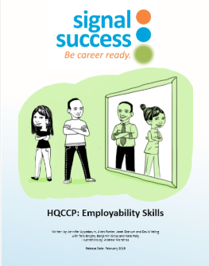  Signal Success is a curriculum designed to help young people develop essential skills for future success. Students receive systematic instruction in core soft skills while engaging in meaningful future planning. Visit http://massconnecting.org/signal-success for a copy of Signal Success customized for Connecting Activities and High Quality College and Career Pathway (HQCCP) programs, and visit http://commcorp.org to learn more about the Signal Success curriculum. | The Massachusetts Career Ready Database  The database is available for use by any youth employment program in Massachusetts.  Visit https://masswbl.org to register to use this database  Visit http://massconnecting.org/database-manual for an introduction to using the database.  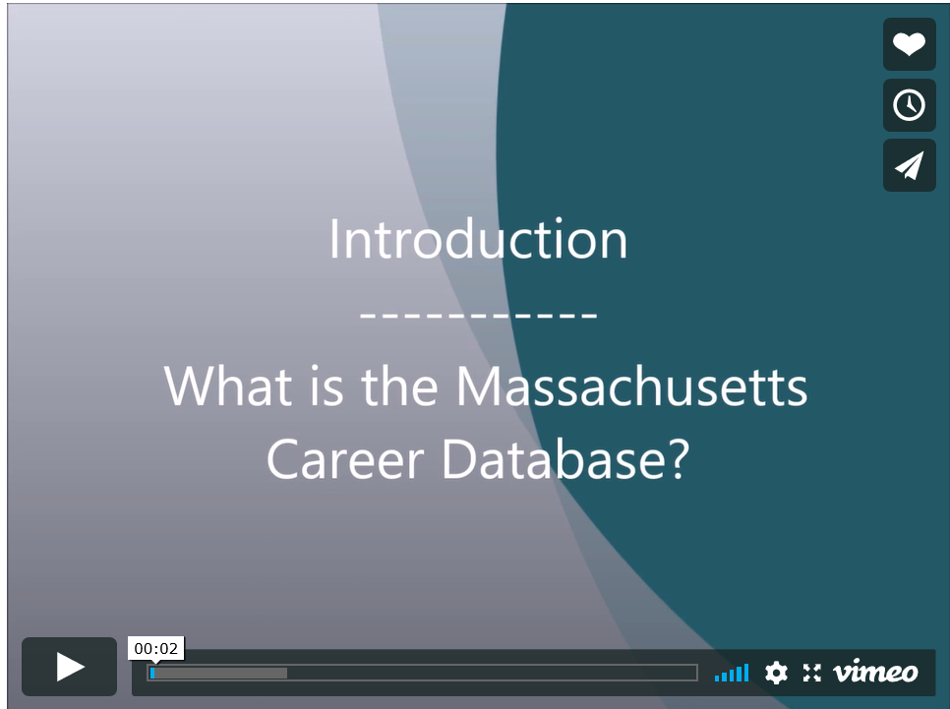

My Career and Academic Plan (MyCAP) Implementation Guide:
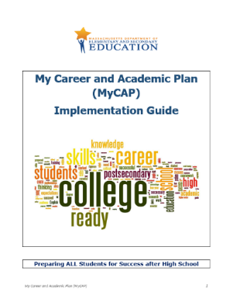
The personal planning tool, My Career and Academic Plan (MyCAP) is key to helping students to plan and reflect on career development experiences and to connect these experiences to their classroom work. MyCAP is a student-directed process of self-discovery, secondary, college and career planning that leads to a unique personalized plan. MyCAP is also an electronic platform that captures a student’s self-identified goals, plans, learning, and documents the achievements of learning objectives at each grade level. The platform may also act as an ePortfolio capturing artifacts and reflections on learning as a result of authentic experiences and achievement of identified competencies. MyCAP encourages students to make the connection between what they do now in school and in daily life and their future success.
Website: http://www.doe.mass.edu/ccte/ccr/mycap/mycap-guide.docx

Contextual Learning Portal  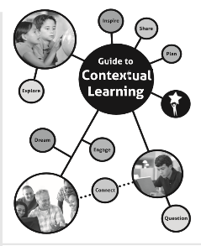  Contextual learning projects engage students in academic work applied to a context related to their lives, communities, workplaces or the wider world. Projects may range in length from a single class period to a semester-long exploration. Projects may take place in after-school or summer programs or in work-based learning programs as well as in a regular classroom.  See the Contextual Learning Portal at http://resources21.org/cl for project examples and to see the Guide to Contextual Learning.  On the same website, look for the Creativity and Innovation projects for a observation at the role of creativity skills in personal, academic, community and career settings:  http://resources21.org/cl/creativityintro.asp | Connecting Activities Annual Reports  Read more about the career development and work-based learning experiences sponsored by Connecting Activities in our annual reports and connect with Connecting Activities staff in your region.  Visit: http://massconnecting.org/annual-report

Perkins V State Plan (for CVTE and HQCCP)
In July of 2018, the "Strengthening Career and Technical Education in the 21st Century Act", also known as Perkins V ("Perkins Five"), was signed into federal law. Perkins V is largely based on the structure and content of prior law, with some key changes that impact the implementation of CTE programs and administrative processes around the country. In Massachusetts, Perkins V is closely aligned with the Commonwealth's High Quality College and Career Pathways work and provides additional opportunities to better prepare students as they acquire the knowledge, skills, and experiences that will enable them to lead productive and fulfilling lives.
With Perkins V there is an opportunity to update the state plan that will guide this work for the next several years. The Perkins V resources support a wide range of programming in Massachusetts, including CVTE programs.

Section 4: Elements of a Strong CDE Program
Whether it is in the context of a CVTE program, an Innovation Pathway or Early College program, or a traditional academic high school program, CDE provides a thoughtful sequence of experiences, designed so that all students have equitable access to exploring future career options and feel confident as they prepare for next steps after high school.
In an exemplary CDE model, students participate in a well-designed sequence of CDE activities that become progressively deeper and more intensive as the students gain skills and maturity. This sequence of CDE activities help students move from the cognitive to the experiential:

Awareness: Students see visual images and messages reinforcing the variety of careers available to them from a young age, participate in events, self-assessments, and other activities to become aware of career opportunities and personal interests, learn about the first steps that might lead to a desired career path.

Exploration: Students learn more about various careers, including career pathways and postsecondary education and training. Through career pathways programs, classes, and workshops, students begin to gather information while also developing career skills.

Immersion: Students gain hands on experience in career areas of interest. Career Immersion includes work-based learning experiences, capstone projects, mentorships, and other opportunities to try out a career area and start to build career skills.

Throughout each of these stages, CDE also addresses student attitudes and beliefs about their future selves, ensuring a personalized approach to their learning process.

Tips for the instructor, mentor, teacher, industry partner
- Before planning an event or activity, brainstorm and have a clear vision of the impact that the event or activity can have in a student’s career development and in their career trajectory.
- Brainstorm ways that a partnership with an industry professional can enhance or hinder a student’s experience.
- Consider partnership development, cultivation, and sustenance.
- Encourage partnerships with industries that are justified by labor market information, highlighting industries such as manufacturing, environmental and life sciences and other industries highlighted in regional economic blueprints and labor market information.
- Consider experiences that will enhance self-concept and increase confidence in career decision making and decision making in general.
- Increase school and district-wide cultural proficiency within all of your offerings. http://www.doe.mass.edu/educators/equitableaccess/resources/culturalproficiency.pdf

Elements of a strong CDE program: Career Awareness

Career Day / Career Fair
A career day or career fair involves the participation of representatives from numerous local and regional businesses and organizations who present information to students. Students can prepare for a career fair by identifying areas of interest and questions they want to ask. Students follow up by writing about areas of interest and recording notes in their college and career plans or reflection journals.
Examples
The Lee Middle School/High School Career Day is an annual event designed to engage middle and high school students with local businesses, colleges, military branches and others to help them learn more about potential career and college paths they may pursue when they graduate from high school. Over 600 students participate, with over 30 companies presenting at this event.
Schools are invited to send groups of up to ten students to the Women in Engineering career day at UMass/Amherst. Highlights of the day include hands-on engineering and computing activities; industry panel and exhibit tables; demonstrations of state-of-the-art technology; information about career opportunities in engineering and computing; and opportunities to talk with alumna and current UMass students and other high school women interested in engineering.
WaterWorks is a regional career day focused on the Blue Economy (water-focused career paths) for the Cape and Islands region, bringing together over 50 exhibitors and students from Barnstable, Dukes, Nantucket and Southeastern Plymouth Counties.
During the Spring 2020 pandemic, the North Central region changed a planned career fair to a virtual fair. Working with the local businesses who had agreed to present at the Career Fair, the Connecting Activities Career Specialist created a video providing an overview of each company, with contact information for each. Students viewed the video before the Career Fair event, and during the virtual event, clicked on links to connect and chat with industry representatives.
Resources
MassHire Greater Lowell Job Fair Video
In collaboration with local employers, MassHire Greater Lowell created a video offering preparation tips for a job fair: https://www.youtube.com/watch?v=UGBAT6vFPSU&feature=youtu.be
Massachusetts Career Ready Database, the Massachusetts Career Ready Database (https://masswbl.org) includes a section for recording CDE Activities. Database users can browse the database to learn about past events in their school, region and beyond, to get ideas for designing and planning career awareness and exploration events and ideas for reaching out to potential presenters from their community.

Career Interest Inventory / Career Interest Assessments
Formal and/or informal career interest surveys and assessments help students discover careers that match their personal interests and strengths. The assessments can be found online and in student portals such as Naviance, MEFA Pathways, or MassHireCIS (see resources below). Once students identify career interests, there can be follow-up activities to help students reflect on their interests and to start to learn about career paths. Students need exposure to the vocabulary associated with career clusters, time to take the survey(s), and time to review and reflect on the results, with adult feedback and support. From this activity will flow additional activities such as the review of labor market information, completing career research projects, or taking additional surveys about skills and values.
Examples
In their course in career theory Marshfield High School students learn different elements of careers over the lifespan, focusing heavily on assessments to help students to gain a more in-depth understanding of their strengths.
Middle school students in Monson complete the O*Net Profile interest inventory and use the website www.virtualjobshadow.com website to view at least one career video based on their interest inventory results.
Resources
MassHire Career Information System
https://portal.masscis.intocareers.org/
MEFA Pathways
http://mefapathway.org
My Next Move
http://www.mynextmove.org
College Board
http://collegeboard.org
ONET
https://www.onetcenter.org/AP.html
Online platforms for college and career planning include:
MEFA Pathway
http://mefapathway.org
MassHire Career Information System:
https://portal.masscis.intocareers.org/
Naviance
http://www.naviance.com
Career Cruising
http://careercruising.com
For students with disabilities, the MA Transition Planning Form (TPF) and Individual Education Plan (IEP) are additional tools that document an individualized path toward postsecondary education and careers. Read more at http://www.doe.mass.edu/sped/secondary-transition/

Career Speakers
A presentation or series of presentations by local professionals about careers. Speakers typically talk about their own experiences and about education and skills needed for entry into their career field. No minimum length is indicated; often these presentations occur during a single class period. Features include opportunities for students to prepare questions ahead of time and opportunities for students to follow up though class discussion, written reflection, or online research.
Examples
Taunton High School students and teachers participated in a forum at Morton Hospital to hear from a variety of speakers in the Healthcare industry, a priority sector. Specialists included a variety of occupations including physical therapists, pharmacy technicians, nutritionists, nurse practitioners, respiratory therapists, interpreters, and an ER physician.
Guest speakers often highlight their own unique career path with applications to career planning for students. At Springfield Public Day High, a career speaker focused on "Chasing your dreams while working full time. Multiple careers paths to finding your purpose," sharing the experience of working as a Correctional Officer and Fashion Designer.
In the Monson Grade 5 President Day Panel, the Presidents of five local companies/organizations spoke about how their career path led to being the president of their business. After each presented their career trajectories, time was allowed for students to ask questions.

Labor Market Information Analysis
Labor Market Information Analysis involves students in viewing and studying Labor Market Information (LMI) through print and online sources. Information may include projected job growth, wages and salaries, job requirements and educational requirements for specific occupations. Information may also include overall trends in key industries and in local, regional, national job markets. Students may use a career interest inventory or assessment to identify career areas of interest and then use print and online labor market information sources to learn more about occupations in these career areas. Students may also use labor market information to learn about overall labor market trends, such as analyzing lists of fastest-growing occupations and wage and salary information across occupations. Analysis of Labor Market Information can be integrated into career development workshops or academic classes, with potential applications to math and statistics, history, geography, civics, technology and other subjects.
Examples
Students from Lawrence High School participated in a workshop to prepare for their Advanced Manufacturing tour. Students explored Labor Market Information about Advanced Manufacturing in Massachusetts, and prepared with questions to ask throughout the tour.
In preparation for Career Day at Durfee High School in Fall River, the Guidance Department collaborated with the History teachers on a labor market lesson to prepare students for the event. Students compared current trends (provided by Bristol WIB) to World War II era trends.
Resources
A Primer for Labor Market Information:
http://www.doe.mass.edu/connect/cde/primer-labormarket.docx
Regional Labor Market Blueprints: represent industry and occupational priorities for workforce investment in seven regions across the Commonwealth: Berkshire, Pioneer Valley, Central, Southeast, Cape, Greater Boston, and Northeast. The Blueprints should be used to inform policy, practice, and funding decisions on a state and local level. For example, a joint application for funding related to workforce development should reflect alignment to the priorities articulated in the blueprints.
https://www.mass.gov/service-details/view-your-regions-blueprint

Service Learning / Community Service / Civic Awareness
Service Learning engages students in projects and curricula designed to respond to community needs while building civic awareness and career awareness for students. Students interact with adults from the community and use critical thinking, teamwork, communication skills and other important career skills in community service projects. Service Learning projects are typically designed to integrate the personal/career skills listed above with academic skills in order to meet identified educational standards.
Community Service is defined more broadly, including work that students may do on their own, through local nonprofit organizations, after-school club and classroom projects, and many other avenues. Many schools offer community service opportunities, and many require that students complete a certain number of hours of community service as a graduation requirement.
Both Service Learning and Community Service provide students with opportunities to build career skills and gain career awareness and civic awareness, while also helping out in their communities.
Examples
The Youth Leadership Academy is a unique program of the Blackstone Valley Education Foundation and seeks to develop the leadership skills of young people and strengthen their connection to the Blackstone Valley. The academy offers students in member schools a challenging curriculum beginning in late fall and culminating in May. Each session is held in a different community where bits of history are shared, strengthening their connection to the Blackstone Valley. Students utilize skills learned during the six month academy to effectively create and implement a community service learning project.
New Bedford Whaling National Historical Park and the UMass Dartmouth Leduc Center for Civic Engagement hosts an Internship & Volunteer Fair for area high school students. Students learn about a variety of opportunities in the local community.The Whaling Museum offers a wide variety of volunteer opportunities for individuals and community service project opportunities for schools and summer youth programs, engaging youth in learning and teaching local history.

Company Tours / Career-Related Field Trips
Company tours include visits and tours at workplaces where students observe workplace activities and listen to presentations by professionals about their work and careers. Other career-related field trips may include trips to museums, science centers, conferences or other educational settings to see or experience career-related technology or projects. Examples include a tour of a biotech company, manufacturing facility or hospital lab. Also, hands-on experiences in a college science lab and engineering days at a science museum. These generally are half or whole day experiences. Students prepare by learning about the company and the industry associated with it and develop questions. Follow up can include a reflection activity. Extension activities can include writing thank you letters, doing research about something they observed or reviewing labor market information.
Examples
During October, in support of Massachusetts’ focus on manufacturing, Blackstone Valley Education Foundation holds Manufacturing Month, with hundreds of middle school students traveling by bus to career exploration programs hosted by large area employers. Students listen to presentations and take part in interactive demonstrations. They are given tours of each facility and are able to view STEM employees engaging in their job responsibilities. Students also have the opportunity to question a panel of employees and managers at each company from an array of STEM departments. The goal of these visits is to expose students and teachers to the skills and education needed for future STEM.
Students in the Farm to Table class at Attleboro High School worked with the owners of a local farm called Big Train Farm, to learn about soil chemistry, produce production and maintenance, and the science behind manipulating microfungal communities in order to maintain plant health.
Resources
Manufacturing Day:
https://www.mfgday.com/
Manufacturing Month:
https://www.mamanufacturing.com/build-your-workforce/
http://commcorp.org/blog/made-massachusetts-commcorp-celebrates-manufacturing-month/
Massachusetts STEM Week:
https://www.massstemweek.org/

Individual Career Coaching/Guidance
One-on-one sessions with a counselor or graduation coach that focus on career development education and personal planning about completing high school and creating post-secondary plans. There are a range of methods for individual coaching. Documentation of counseling activities via a career plan or career portfolio is highly recommended.
Examples
The Connecting Activities Career Specialist at Attleboro High School meets with students in a series of one-to-one meetings to work on career readiness skills including but not limited to employment searches, resume writing, interview preparation, and career/post-secondary research.
Mansfield High School’s Career Counseling program provides one-to-one meetings with students to discuss career or job-related interests. This includes job referrals, resume writing, improving interview skills, arranging job shadows and informational interviews, providing career profiles, and post-graduation career planning.
Resources
Coaching for College and Careers: A Skillsworks Toolkit is a useful tool for career exploration. https://www.sabes.org/content/coaching-college-and-careers-skillswork-toolkit
Massachusetts Association for School Counselors (MASCA):
https://masca.wildapricot.org/MA-Model-2.0
MassHire Career Information System
The MassHire Career Information System (MassHireCIS) provides assessments, search tools and labor market information specific to Massachusetts. Students can create an account or simply sign in using their city/town and zip code. Read more on the mass.gov website at https://www.mass.gov/service-details/masshirecis-masshire-career-information-system Visit this website at https://portal.masscis.intocareers.org/
MassHire One-Stop Career Centers
One-Stop Career Centers across the Commonwealth provide ongoing trainings on Labor Market Information.
SABES Labor Market Information Workshops
For practitioners in the Adult Education system, SABES www.sabes.org offers Labor Market Information workshops throughout the year.
The Occupational Outlook Handbook
The Occupational Outlook Handbook (on the O*NET website at http://www.onetonline.org/ ) is a useful tool for helping students learn about careers, skill requirements, and salaries for various occupations.

Elements of a strong CDE program: Career Exploration

Career Exploration Courses
Courses on general career development topics, including exploring career options, job search skills and career strategies. Courses can be a semester or year-long class, and are treated like other courses, with a syllabus, required assignments and a final grade.
Examples
Taunton Alternative High School offers a Career Skills course, providing students with career awareness and career exploration activities. The course covers everything from interest inventories to career skill development and work readiness training to portfolio building and career planning.

Career Skills Workshops
Workshops, classes, events or coaching focused on resume writing, job search strategies, interviewing skills, professionalism, communication skills and other essential career skills. May include mock interviews with professionals from the community, peer-to-peer resume review and other opportunities for practice and feedback. Workshops and classes require students to complete products or participate in activities in order to practice skills and reinforce learning, along with feedback through a formal rubric or feedback process. The online portal which houses the student’s MyCAP stores the artifacts that are created for the different topics listed above.

Examples
During the Spring 2020 pandemic crisis, the Merrimack Valley MassHire Board`s Connecting Activities staff adapted their series of career workshops to an online platform. Through their newsletter they reached out to area organizations and partners to offer this new virtual workshop series for youth.
Participants in YouthWorks and other summer jobs programs meet regularly throughout the summer for Signal Success workshops. Through these workshops, participants gain career skills, including the skills they use in their current work experiences as well as resume writing, interviewing and career exploration skills they will use throughout their careers.

Financial and Economic Literacy Events and Workshops
Financial and economic literacy education includes workshops and events helping students to learn about financial management, loans (including college loans, mortgages, and car loans), credit cards, personal budgeting and cost of living realities; often provided in conjunction with career awareness and career goal setting. Students are given an introduction to concepts via a workshop or fair.

Examples
Blackstone Valley Education Foundation holds an annual Business & Education Forum. In 2019, to support the new financial literacy education state guidelines, the theme surrounding The Role of Financial Literacy in Workforce Development was discussed. Ideas stemming from round-table discussions resulted in a session on financial literacy for our Blackstone Valley Youth Leadership Academy students as well holding a Professional Development session for educators to learn new strategies and share best practices on how to teach financial literacy skills to our youth. Unibank was a key contributor in both sessions.
Seniors at BMC Durfee High School participate in the Credit for Life personal finance fair, which is a culminating event for the financial literacy curriculum the students complete during their senior year. Connecting Activities supports event planning and facilitates the Employment Booth. The Employment Booth provides and critiques sample job applications and discusses the realities of part time employment. The event is organized and sponsored by Baycoast Bank. Multiple community partners/ businesses volunteer to run the other booths.
Resources
Personal Financial Literacy in the Massachusetts Curriculum Frameworks:
Signed into law by Governor Baker on January 20, 2019, Chapter 438 of the Acts of 2018, An Act Relative to Financial Literacy in Schools, requires the Department of Elementary and Secondary Education to assist schools in the selection of materials and curriculum on personal financial literacy, and resources for professional development activities. This document lists standards from the Massachusetts Curriculum Frameworks associated with the following topics addressed in the law: (1) loans; (2) interest and interest accrual; (3) credit card debt; (4) online commerce; (5) rights and responsibilities of renting or buying a home; (6) saving, investing and planning for retirement; (7) the role of banking and financial services; (8) balancing a checkbook; (9) state and federal taxes; (10) charitable giving; (11) evaluating media content, including online content, that relates to personal finance matters; and (12) saving, investing and planning for higher education or professional training.
Website Link: http://www.doe.mass.edu/frameworks/financial-literacy.docx

Job Shadow Day
A job shadow is a career exploration activity in which students spend several hours or more at a workplace following and observing an employee through his or her workday. Example: Groundhog Day Job Shadow Program. Job shadow experiences often occur for a half or whole school day, with opportunity for reflection after the experience. Students should follow up by writing thank you notes to their hosts and by writing about the experience in a reflection essay, journal, portfolio and/or in their college and career plan.
Examples
The Boston Private Industry Council (PIC) organizes citywide job shadowing opportunities in health care, professional services, finance, real estate and other key sectors of the Boston economy. The PIC focuses on recruiting employers who plan to hire students over the summer and/or employers who are strongly considering hiring students for the first time. This targeted employer approach aligns the job shadow experience with summer job hiring by considering the job shadow as a "first look" for both students and supervisors.

Mentorship programs
Mentorship programs connect students with adults in workplaces who serve as mentors and who introduce students to their workplace and its industry while developing a supportive personal relationship.
Examples
Career Mentoring is the Taunton Area School to Career (TASC) signature partnership service; matching the volunteers, predominantly local business professionals, with students on a one-to-one basis. Once matched, the mentor and his/her mentee meet about twice a month to explore education and career options and learn essential work skills. They tour area businesses, organizations, colleges, and trade schools – all arranged by TASC. They also have individual meetings, focused on meeting the needs and goals of the mentee. Career Mentors build a relationship and have an opportunity to “make a difference,” and possibly a life-altering one, in the life of a local young person.

Mock Interviews / Informational Interviews
Mock Interviews are practice interviews with career professionals, in which the career professional interviews a student, practicing professional interviewing skills.
Informational Interviews are one-on-one or small group interviews, in which a student or job seeker asks questions to an industry professional about his or her career. Interviews may be in person, on the phone or online. Questions are researched and prepared ahead of time, answers are recorded and a reflection is written, with adult staff support.
Examples
Through the school's Career Counseling program, Mansfield High School students are matched with career professionals to conduct informational interviews. Students create developed questions to ask the professional before the interview. They will either call, video chat, or meet in person to discuss their inquiries.

Vocational Exploratory Courses
In schools with five or more Career/Vocational Technical Education (CVTE) programs, students explore the programs through an Exploratory course. Students visit each program, learn about the program and the career opportunities offered and try out some hands-on activities that give a flavor of the program. Students use reflection journals or career interest questionnaires to reflect on their personal interests and choose a program at the end of the Exploratory course.
Examples
At Madison Park Technical Vocational High School, Grade 9 students visit each vocational program during September to get a broad overview of programs offered. After this rotation, students complete a Career Interests and Values questionnaire and identify programs they would like to explore further. Based on their choices and their career interests and values, they are assigned an individually-tailored schedule that includes their top choices programs plus one or two non-traditional choices that align with their interests and values but that they might not have considered. In this next round of rotations, students learn more about each program and try out a variety of hands-on activities before making program selections.

Elements of a strong CDE program: Career Immersion

Capstone Projects / Senior Projects
Major projects that bring together skills and knowledge from across subject areas and domains. Often completed in senior year, these projects may include performing a hands-on project, writing a research paper, researching related career options and developing a portfolio of project materials. The parameters of these projects may vary from one school to another, but share the idea that students devote several months to a project with a final product and complementary research, reflection and other writing. Examples: See the Contextual Learning Portal and search for projects tagged as Capstone or Senior-Projects. Capstone projects are typically a quarter or semester-long project for academic credit; minimum is typically defined in relation to the number of hours needed for credit by the school offering the opportunity.
Examples
The Senior Capstone program at Martha’s Vineyard Regional High School is a multidisciplinary semester-long course in which students have the opportunity to pursue a project of their own interest. The Senior Capstone course may be taken either as an elective or as an English class.
All students at Danvers High School complete a capstone project, internship or independent study project prior to graduation. Students who chose a capstone project chose a topic aligned with their college and career interests and work with a faculty advisor to complete a project with at least 100 hours of work. To prepare for this experience, one of the elective grade 12 English courses, titled College, Career and Communication, focuses on career exploration, career skills and communication skills.
Resources
Martha`s Vineyard Capstone:
https://www.mvrhs.org/capstone/

Co-Curricular Activities and Clubs
Many Co-Curricular Activities and Clubs provide students the opportunity to practice career-related skills, meet professionals in their field of interest, and connect with other students with similar interests.
Examples
SkillsUSA is a national club for students in Career/Vocational Technical Education Pathways. Students compete in challenges in regional and national competitions.
Weymouth High School launched a Girls Who Code Club, for girls interested in computer programming.
Mashpee High School students participate in several co-curricular clubs that are connected to the school`s engineering program, including a Makerspace Club and a Robotics Club.
Resources
CVTE Student Organizations:
http://www.doe.mass.edu/ccte/cvte/studentorgs.html
The Makerspace for Education site at http://www.makerspaceforeducation.com/ is a resource developed by teachers from British Columbia, recommended because of the for-teachers-by-teachers flavor of the site.

Entrepreneurship Programs
Entrepreneurship programs provide career skills and experience in the context of a student-run business.
Examples
Students in the Financial Algebra class at Ralph C. Maher Regional High School develop a business and showcase the plans and marketing materials for judging.
Old Colony Regional Vocational Technical High School`s LAUNCH is an early college program where up to 20 students will concurrently take classes with Bristol CC in small business and entrepreneurship to graduate with both a high school diploma and BCC certificate in addition to career exploration in entrepreneurship. Two teachers/staff from the high school will also participate in the program.
Many communities offer entrepreneurial projects within the local summer jobs programs. For example, the ArtWorks program in the Cape and Islands region pairs small groups of students with professional artists to create, market and sell artistic products, including fine arts, graphic design and more. The Taunton Area School to Career (TASC) Jams & Jellies initiative employs students in a student-run business, creating jams and jellies that are sold at the local farmers market.

Skills Portfolios
A Skills Portfolio is an organized collection of samples of student work, which may include writing, project photos, a resumé and other materials, bringing together experiences and accomplishments from a variety of school, workplace and/or community settings. A Skills Portfolio is often a product of one of these career immersion experiences, such as a portfolio of materials from a capstone project, from an internship experience, or from career-themed courses, pathways or programs.
Examples
Students at Berkshire Arts and Technology Charter Public School begin developing portfolios in Grade 6 and present their portfolios to community members at the end of Grade 12 prior to graduation.

Industry-Recognized Credentials
In Career/Vocational Technical Education programs, Innovation Pathways, Early College, and other types of career pathways, and in many career-themed courses, students earn industry-recognized credentials that can give them an advantage in first jobs and in long-term career development. Industry-recognized credentials are varied, including, for example, general workplace safety through the Occupational Safety and Health Administration (OSHA); certification in health care skills including first aid and CPR; credentials in computer programming languages, graphic design software; construction safety certificates; and, in many occupations, licensure or apprenticeship credits.
Examples
Students in Health Assisting and Medical Assisting vocational programs earn a series of credentials, reflecting the idea of "stackable credentials" including CPR, First Aid and Heartsaver certificates, certification in a Medical Assisting software program, and Home Health Aide, Certified Nurse Assistant and/or Patient Care Technician credentials.
Students in Automotive Technology programs earn "stackable credentials" valued by auto repair shops, dealerships and other employers. Through the Automotive Service Excellence (ASE) professional test series, students can earn credentials in topics including Engine Repair, Brakes, Suspension & Steering, and Electrical/Electronic Systems. Students also earn an OSHA certificate, a Hot Works certificate and a variety of product-specific certificates.
Participants in the summertime "Jams and Jellies" entrepreneurial program in Taunton earn a food handler certificate in order to be able to safely produce and sell food products.
Resources
The Vocational Technical Education (VTE) Frameworks describe industry-related credentials related to each program in the appendix of each framework document.
http://www.doe.mass.edu/ccte/cvte/frameworks/
The Massachusetts Department of Elementary and Secondary Education (DESE) SIMS reporting system includes a list of industry-recognized credentials that may be reported through SIMS. Find the list in the SIMS Handbook:
http://www.doe.mass.edu/infoservices/data/sims/

Work-Based Learning Experiences
Work-Based Learning experiences are workplace experiences designed to help students gain work experience, build skills and/or explore career options. These experiences may include internships, summer jobs, after-school jobs, school-based enterprises and volunteer work. Students perform work in a workplace or work-like setting, with genuine job responsibilities toward customers, co-workers and/or supervisor. In Massachusetts, Work-Based Learning experiences are often structured by the Work-Based Learning Plan, which provides a job description, list of skills/tasks, and performance evaluation.
Examples
Through the Connecting Activities Initiative, each year over 10,000 students participate in Work-Based Learning at over 5,000 employer sites.
Tech Apprentice is a six- to seven-week paid summer internship program for tech-savvy Boston Public Schools (BPS) high school students who want to work at local companies. These talented students are considering pursuing IT majors in college, and they need a work-based experience to help them understand the options available to them in the high-tech arena.
Southwick Regional High School’s Diversified Learning Experience Program is a highly structured internship program designed to provide students the opportunity to gain experience and develop competencies essential to success in the workplace. Students usually spend two periods of the day in academic classes and attend work-based learning experiences during the remaining time for a full semester. Students spend part of their release time in a seminar series designed to help develop an understanding of the essential personal and interpersonal skills necessary for job success. In addition, students will design and produce an effective resume, cover letter, and reference sheet. Each student is also responsible for maintaining a daily journal, completing a career display project, and preparing a formal presentation on internship experiences and skills gained. The Massachusetts Work-Based Learning Plan (MWBLP) is used to evaluate the student skills.
Resources:
Elements of Model Internships
This guide, found at http://massconnecting.org/internships, provides tips for starting an internship program, along with examples of forms and materials from programs throughout Massachusetts.
The Massachusetts Work-Based Learning Plan Resource Guide
This guide, found at http://massconnecting.org/wblp, provides links to the Massachusetts Work-Based Learning Plan, along with suggestions about how to use the Work-Based Learning Plan in a work experience program.
The Massachusetts Career Ready Database
This database provides screens for entering information about work-based learning experiences, including placement details and employer information, along with screens for the online version of the Massachusetts Work-Based Learning Plan. The database is available at no cost for use by any youth employment program in Massachusetts. Visit https://masswbl.org to register to use this database and visit http://massconnecting.org/database-manual for an introduction to using the database.

Virtual Internship
A virtual internship is a work-based learning experience in which the youth is not necessarily physically present at the worksite of a business or organization. Connecting Activities defines a virtual internship as any work experience that provides several or all of the features of a traditional internship, but with an alternative physical location, alternative supervisor or mentor relationship, or alternative choices of work projects and tasks.
Resources:
As Massachusetts practitioners develop models for virtual internships, we will continue to post materials on the massconnecting.org website’s resources and news pages at http://massconnecting.org/resources and http://massconnecting.org/news including the following:
  - Connecting Activities Models During Pandemic
  - IP Toolkit – Remote Learning Guide
For project ideas, see the YouthWorks Summer 2020 Project Guide, available at https://commcorp.org/youthworks

Elements of a strong CDE program: Connecting Schools, Families & Community

Family Events: Career Awareness for Students and Families:
Workshops and events offered to students and families, often to inform them about the relationship between completion of a rigorous course of study, pursuit of postsecondary education and access to careers that offer prospects for successful futures. Often occurring on a single evening, family-focused events can also be a program that extends over a series of several meetings or workshops.
Examples
In Whitman Hanson Regional High School`s "Coffee with Counselors" series, school counselors meet with Grade 9, Grade 10, Grade 11, and Grade 12 parents, focusing on different grade-related topics with each cohort of parents.

Middle School Events: Career Awareness and Planning/High School Choices:
Workshops, high school visits and other events focused on the value of exploring career choices early, to help students and their families make decisions about the kind of high school to attend, and the connection between high school choices and postsecondary plans. Career awareness at the middle school level is often a program designed by a district’s counseling department as part of students’ transition from middle to high school. Ideally, MassCore and local graduation requirements are reviewed and at the end of 8th grade students/families will map out a preliminary four year plan and a 9th grade schedule.
Examples
The Berkshire Compact for Education holds an annual set of 8th Grade Career Conferences for students from South, Central and North County, at Berkshire Community College and at the Massachusetts College of Liberal Arts. Students pre-register for two career areas and attend workshops with professional speakers based on these choices.
In North Adams, Drury High School peer mentors met with all 8th graders within the district and partnering districts to highlight what to expect in high school, life, and college & career preparation.

Teacher Externship Programs
Teacher Externships are a reverse internship for teachers. Teachers connect with a local business and spend time shadowing or working on a special project for the company. Through this experience, the teacher gathers information about the workplace and uses this information to develop career-themed lesson plans for their classroom.
Examples
In collaboration with Fitchburg State University, DESE sponsors a summer externship program for teachers in Career/Vocational Technical Education programs. Teachers work for at least 50 hours with a host employer and develop one or more unit plans inspired by the experience.
Resources
Lesson Plans from recent Perkins Externship program can be viewed on the Contextual Learning Portal at http://resources21.org/cl/externships

Elements of a strong CDE program: The MyCAP Planning Process
My Career and Academic Plan (MyCAP) is an important tool for empowering students, helping students to set goals and to reflect on their career development and academic work and accomplishments.
My Career and Academic Plan (MyCAP) is a student-centered, multi-year planning tool designed to provide students with ongoing opportunities to plan for their academic, personal/social and career success. The MyCAP tool consists of both a process and an electronic platform. The electronic platform provides a place to organize and record progress related to academic achievement, personal/social skill development, and career development information that leads to workplace readiness. However, it is within the process that students: set attainable goals based on individual interests and strengths; engage in activities that promote academic achievement, personal social skill development and career development education; promote communication between students, school staff, parents, and other influential adults; and support school and district improvement efforts that are responsive to students’ interests and needs.

ABOUT MyCAP

MyCAP or My Career and Academic Planning is a student-directed process of self-discovery and college and career planning that leads to a unique personalized path towards post-secondary success. As an instrument, MyCAP captures the learning and documents the achievements of the learning objectives at each grade level. The instrument may also act as an ePortfolio capturing certain artifacts that demonstrate success. The ePortfolio may be part of an online career information system or a cloud storage system (e.g. google docs) or in a “Linked-In” type system. MyCAP empowers students to connect learning and future interests through exploring, identifying and developing an individual’s pathway to success.
Core Components of MyCAP:
● is student-driven: it is the individual student’s self-defined goals and unique interests that guide his/her plan for academic, personal/social, and workplace readiness skill attainment.
● Is guided: Every student has at least one key adult on the school staff, typically referred to as a school mentor to encourage, to support, and to guide MyCAP development.
● at least one online college and career planning system (i.e. MEFA Pathways, MassCIS, Naviance) is selected to be the MyCAP electronic platform. The system includes an ePortfolio to capture artifacts that document the student’s progress over time.
● is developed within a structured program using a curriculum that offers lessons and activities through classroom instruction, outside resources and an online electronic platform to ensure every student is on a path to college and career readiness by grade 12.
Learn more at http://www.doe.mass.edu/ccte/ccr/mycap/mycap-guide.docx

Section 5: A Local Vision for Career Development
This guide provided a wide array of concepts, resources and examples to help schools and districts to plan a system of Career Development Education, and introduced some of the programs, initiatives and communities of practice that support the work.
Currently, physical schools are closed due to COVID-19 and students are learning online and preparing for a summer with online and virtual summer learning and work experiences.

It is anticipated that educators will show creativity in designing learning experiences for students that provide a meaningful blend of academic and career skills, with experiences that help students see how their skills will be important across domains to prepare them to find opportunities in both difficult economic times and in a thriving economy.

Attention to equity of opportunity is more important than ever, as the challenges of this time have shed light on, and in some cases, magnified serious economic gaps. A thoughtfully-designed program of career development education will ensure that all students have access to participate, that all can see themselves in available opportunities, and that each student is supported in establishing their personal, academic and career goals and in taking important first and next steps.

The staff of each of the programs and initiatives described in the guide, and the workforce partners who are essential to this work, consider it a privilege to share resources and provide support to schools and districts in support of young people in this work.

